

Department of Computing and Information Sciences
Semester II 2025-2026
CSDS3204 – Data Warehouse Design

Patient Appointment Behaviour Analysis

Contents
1. Introduction 3
2. Dimensional Model 3
3. SQL Server Integration Project 6
4. SQL Server Analysis Project 7
5. Reporting Services Project 9

Introduction
This project focuses on building a data warehouse to analyse patient appointment behaviour in a healthcare environment. It involves integrating and organising appointment-related data to support efficient analysis and reporting. The system will use SSIS for data extraction and transformation, SSAS for analytical processing, and SSRS for generating reports and visual insights. The goal is to provide a structured foundation for understanding appointment patterns and supporting better decision-making in healthcare management.

Dimensional Model
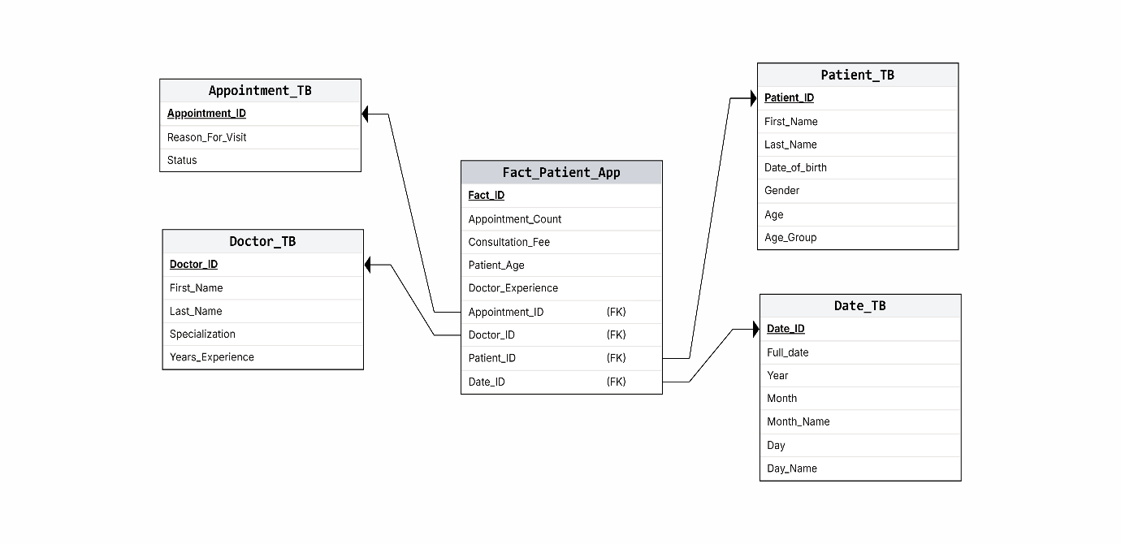
use master;
go;
Create Database PatientAppointmentDW;
use PatientAppointmentDW;
go;
------------------------------------------------------------------------------------
Create Table Patient_TB_Source (Patient_ID INT IDENTITY(1,1) PRIMARY KEY,First_Name VARCHAR(50), Last_Name VARCHAR(50), Gender CHAR(1), Date_Of_Birth DATE);

Create Table Patient_TB (Patient_ID INT IDENTITY(1,1) PRIMARY KEY,First_Name VARCHAR(50), Last_Name VARCHAR(50), Gender CHAR(1), Date_Of_Birth DATE,Age INT,Age_Group NVarchar(50));

INSERT INTO Patient_TB_Source(First_Name, Last_Name, Gender, Date_Of_Birth) VALUES
('Ahmed','Al-Said','M','1985-02-10'),
('Fatima','Al-Harthy','F','1992-06-15'),
('Salim','Al-Balushi','M','1978-09-21'),
('Aisha','Al-Rawahi','F','1988-12-01'),
('Khalid','Al-Zadjali','M','1969-03-30'),
('Mona','Al-Hinai','F','1995-07-18'),
('Yusuf','Al-Farsi','M','1982-11-11'),
('Noor','Al-Lawati','F','2000-01-25'),
('Hassan','Al-Busaidi','M','1975-05-05'),
('Zahra','Al-Kindi','F','1998-08-09'),
('Omar','Al-Rashdi','M','1983-04-14'),
('Layla','Al-Maamari','F','1991-10-22'),
('Saif','Al-Yahyai','M','1970-02-02'),
('Amal','Al-Ghafri','F','1986-06-06'),
('Nasser','Al-Siyabi','M','1993-09-17'),
('Hamdan','Al-Abri','M','1987-03-12'),
('Reem','Al-Habsi','F','1996-11-08'),
('Majid','Al-Kaabi','M','1981-01-19'),
('Huda','Al-Shukaili','F','1994-05-27'),
('Tariq','Al-Badi','M','1979-08-03');

select * from Patient_TB_Source;
select * from Patient_TB;
-------------------------------------------------------------------------------------
Create Table Doctor_TB (Doctor_ID INT IDENTITY(10,1) PRIMARY KEY,First_Name VARCHAR(50), Last_Name VARCHAR(50), Specialization VARCHAR(100), Years_Experience INT);

INSERT INTO Doctor_TB (First_Name, Last_Name, Specialization, Years_Experience) VALUES
('Ali','Hassan','Cardiology',15),
('Fatima','Saeed','Pediatrics',10),
('Omar','Rahman','Dermatology',8),
('Layla','Khan','Orthopedics',12),
('Hamad','Al-Farsi','Neurology',18),
('Sara','Al-Harthy','General Medicine',7);

select * from Doctor_TB;
-------------------------------------------------------------------------------------
Create Table Appointment_TB (Appointment_ID INT IDENTITY(100,1) PRIMARY KEY,Reason_For_Visit VARCHAR(100), Status VARCHAR(20));

INSERT INTO Appointment_TB (Reason_For_Visit, Status) VALUES
('Checkup','Completed'),
('Consultation','Completed'),
('Emergency','Completed'),
('Follow-up','Scheduled'),
('Therapy','Cancelled'),
('Vaccination','Completed'),
('Dental','Completed'),
('Eye Exam','Completed'),
('Surgery','Scheduled'),
('Skin Treatment','Completed'),
('Physiotherapy','Completed'),
('Blood Test','Completed'),
('X-Ray','Completed'),
('MRI Scan','Scheduled'),
('Ultrasound','Completed'),
('General Check','Completed'),
('Flu Symptoms','Completed'),
('Injury','Completed'),
('Back Pain','Completed'),
('Allergy','Completed');

select * FROM Appointment_TB;
-------------------------------------------------------------------------------------
Create Table Date_TB(Date_ID INT PRIMARY KEY,Full_Date DATE,Year INT,Month INT,Month_Name VARCHAR(15),Day INT,Day_Name VARCHAR(15));
DECLARE @StartDate DATE = '2023-01-01';
DECLARE @EndDate DATE = '2026-12-31';

WHILE @StartDate <= @EndDate
BEGIN
INSERT INTO Date_TB
VALUES (
CONVERT(INT, FORMAT(@StartDate, 'yyyyMMdd')),
@StartDate,
YEAR(@StartDate),
MONTH(@StartDate),
DATENAME(MONTH, @StartDate),
DAY(@StartDate),
DATENAME(WEEKDAY, @StartDate)
);

SET @StartDate = DATEADD(DAY, 1, @StartDate);
END;

SELECT * FROM Date_TB;
-------------------------------------------------------------------------------------CREATE TABLE Fact_Patient_App (
Fact_ID INT IDENTITY(1,1) PRIMARY KEY,
Patient_ID INT,
Doctor_ID INT,
Appointment_ID INT,
Date_ID INT,
Appointment_Count INT,
Consultation_Fee DECIMAL(10,2),
Patient_Age INT,
Doctor_Experience INT,

FOREIGN KEY (Patient_ID) REFERENCES Patient_TB(Patient_ID),
FOREIGN KEY (Doctor_ID) REFERENCES Doctor_TB(Doctor_ID),
FOREIGN KEY (Date_ID) REFERENCES Date_TB(Date_ID),
FOREIGN KEY (Appointment_ID) REFERENCES Appointment_TB(Appointment_ID)
);
INSERT INTO Fact_Patient_App (
Patient_ID,
Doctor_ID,
Appointment_ID,
Date_ID,
Appointment_Count,
Consultation_Fee,
Patient_Age,
Doctor_Experience
)
SELECT TOP 200
p.Patient_ID,

d.Doctor_ID,
a.Appointment_ID,
dt.Date_ID,

1 AS Appointment_Count,

CASE
WHEN a.Reason_For_Visit IN ('Emergency','Surgery') THEN 500
WHEN a.Reason_For_Visit IN ('MRI Scan','Ultrasound','X-Ray') THEN 300
WHEN a.Reason_For_Visit IN ('Consultation','Checkup','General Check') THEN 100
ELSE 50
END AS Consultation_Fee,

DATEDIFF(YEAR, p.Date_Of_Birth, dt.Full_Date),

d.Years_Experience

FROM Patient_TB p

JOIN Doctor_TB d
ON d.Doctor_ID = ((p.Patient_ID - 1) % (SELECT COUNT(*) FROM Doctor_TB)) + 10

JOIN Appointment_TB a
ON a.Appointment_ID = ((p.Patient_ID - 1) % (SELECT COUNT(*) FROM Appointment_TB)) + 100

JOIN Date_TB dt
ON dt.Date_ID = (
SELECT TOP 1 Date_ID
FROM Date_TB
ORDER BY NEWID()
);

select * from Fact_Patient_App;

SQL Server Integration Project
In SQL Server Integration Services, the Extract, Transform, and Load (ETL) process. An OLE DB connection was used as both the data source and destination to handle the movement of data between the operational database and the data warehouse using the Patient table source. During the ETL process, patient data was extracted and then filtered to include only patients born after 1980. A derived column was added to calculate the patient’s age based on their date of birth, and another transformation was applied to create age groups based on the calculated age. Finally, the transformed data was loaded into the Patient table in the data warehouse for further analysis and reporting.
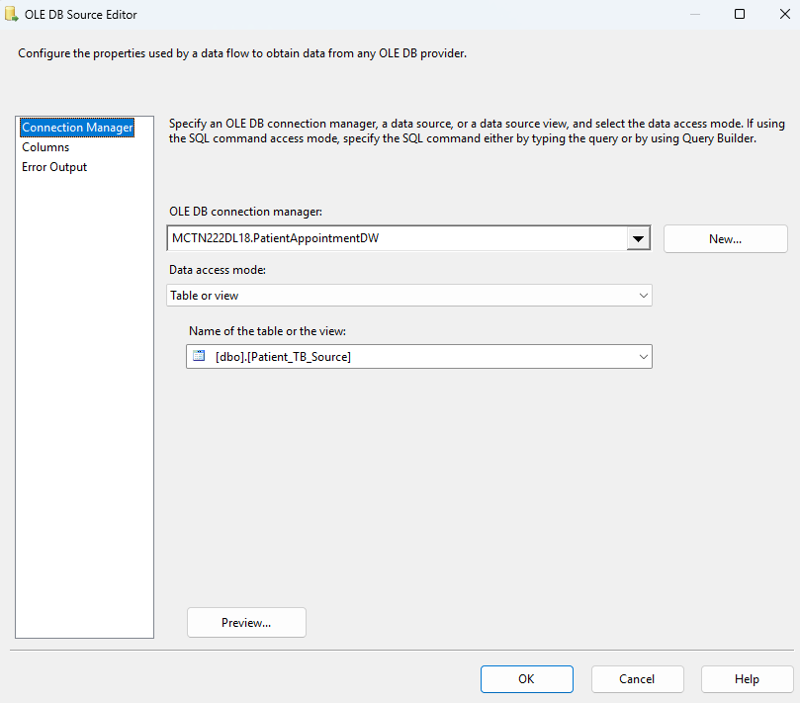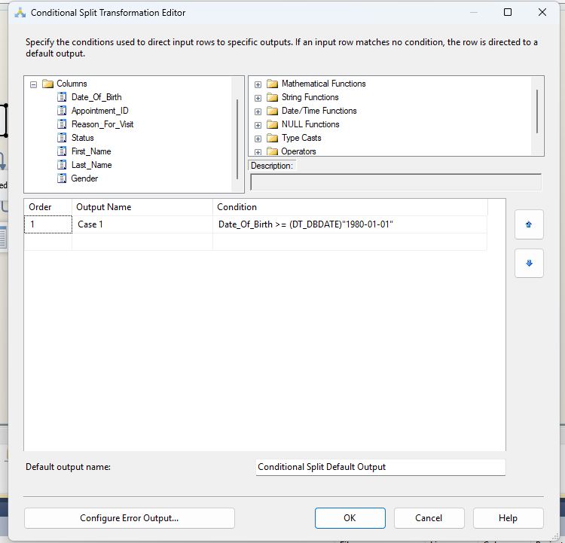
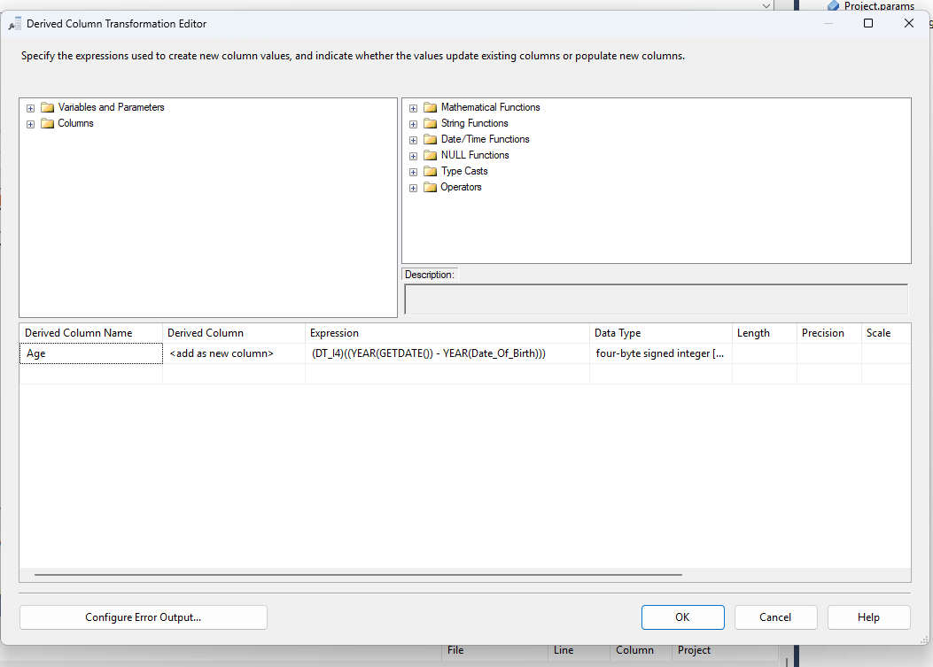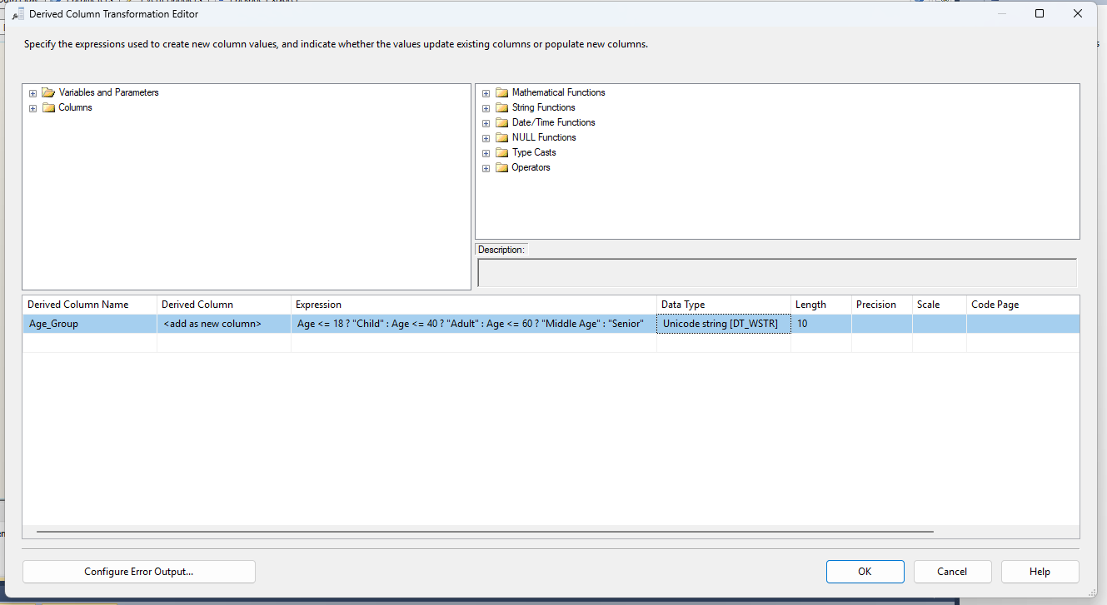
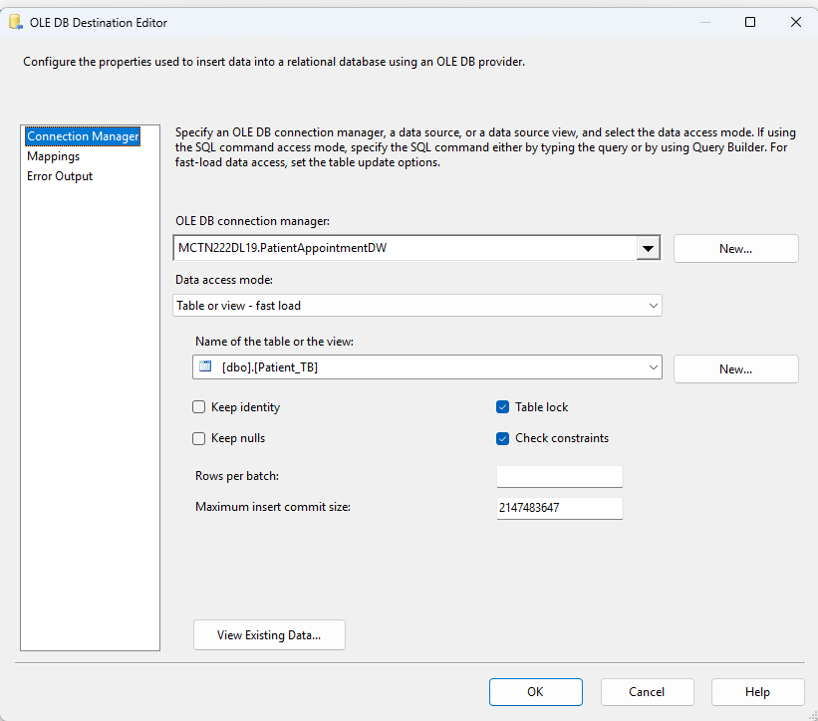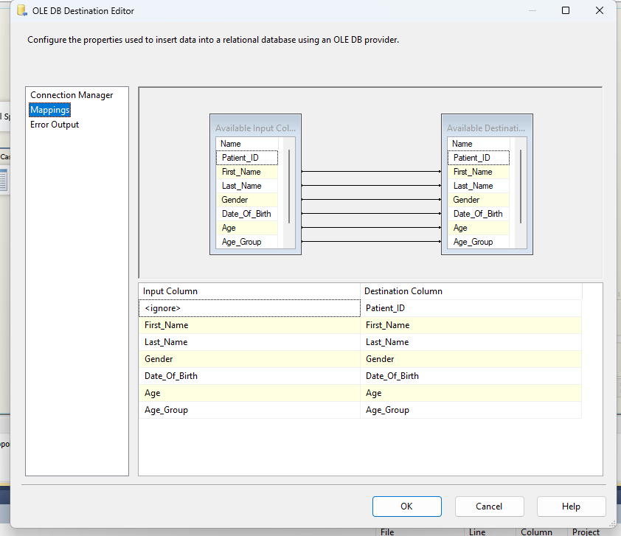
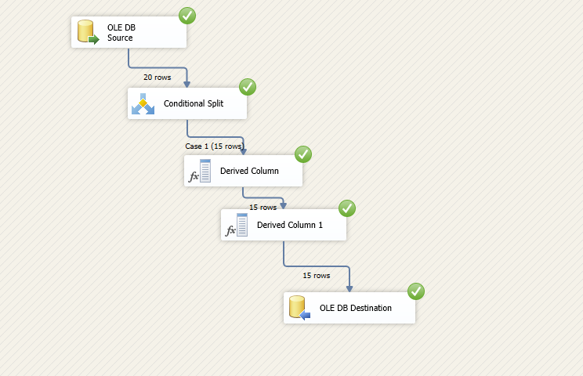

SQL Server Analysis Project
All relevant data sources were successfully integrated into the Patient Appointment DW cube, including the Fact Patient App measure group and the associated dimension tables: Patient TB, Appointment TB, Date TB, and Doctor TB. This integration enables efficient multidimensional analysis, supporting advanced querying and KPI development within the cube environment.
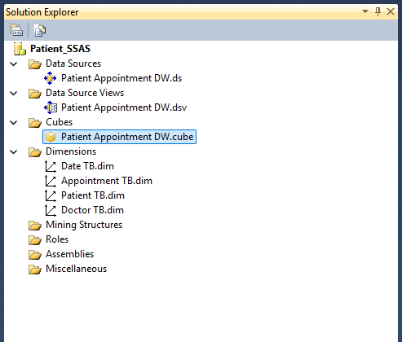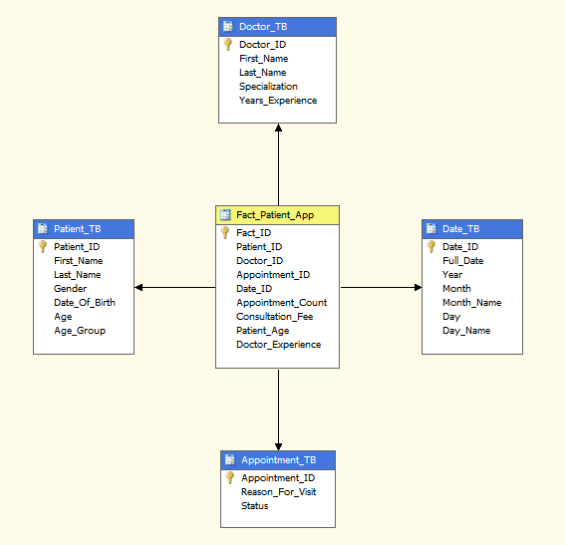
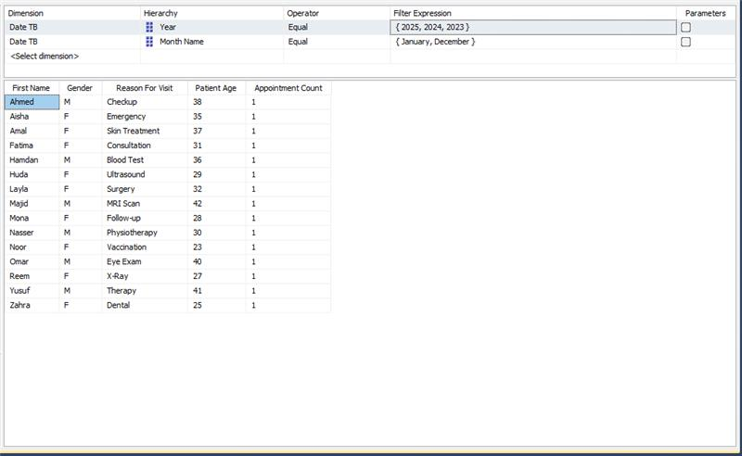
The analysis was limited to appointments occurring in January and December across the years 2023, 2024, and 2025. It focuses on examining patient demographics (such as gender and age) and reasons for visits to identify patterns in healthcare demand at the beginning and end of the year. This helps highlight seasonal variations and differences in service utilization during these specific periods.
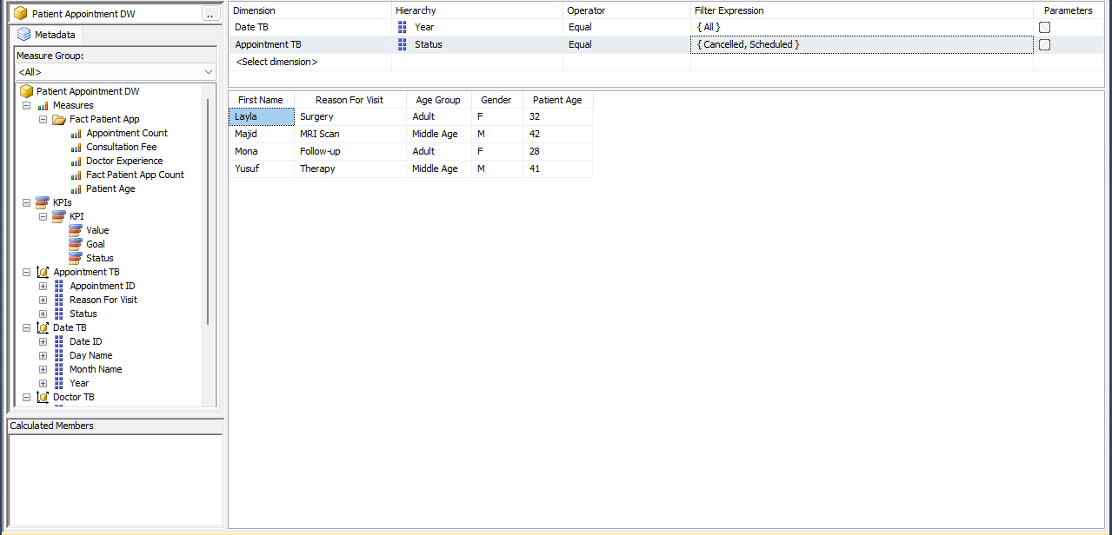
The analysis focuses on appointments with Scheduled and Cancelled statuses across all available years. It examines patient characteristics such as age group, gender, and reason for visit to understand differences in appointment outcomes and identify patterns in cancellations versus successfully scheduled visits.
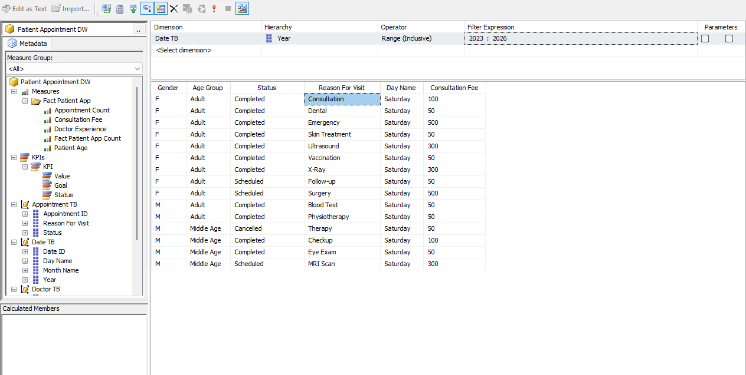
The analysis covers appointments from 2023 to 2026 and focuses on completed, scheduled, and cancelled visits. It examines variations in consultation fees based on factors such as gender, age group, day of the week, and reason for visit, to identify patterns in service pricing and patient utilization across different conditions.
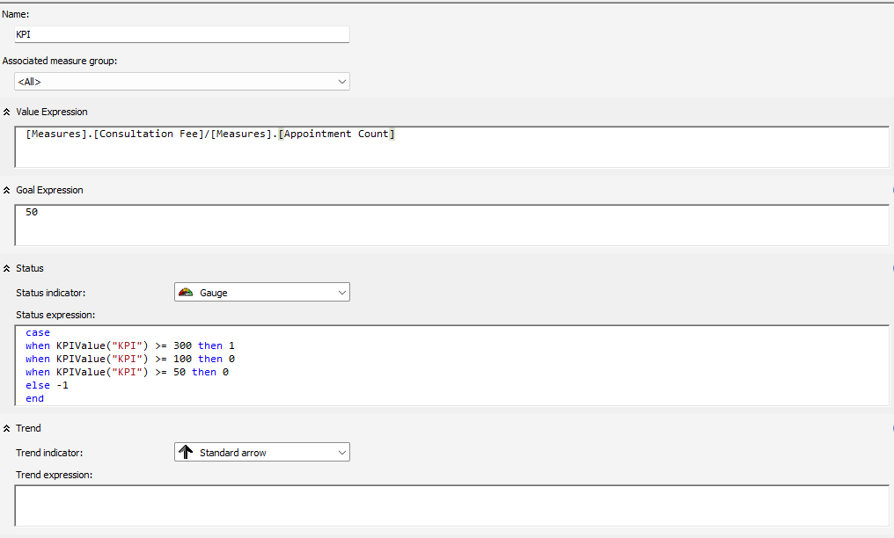
This KPI evaluates the average consultation fee per appointment by dividing the total consultation fees by the number of appointments. The target value is set at 50, serving as a benchmark for acceptable performance. Currently, the KPI value is approximately 166.67, which significantly exceeds the target, indicating strong performance.

Reporting Services Project
The Patient Analysis Report was developed in SSRS to provide meaningful insights into patient demographics and service utilization patterns. In this report, patient data is grouped first by age group and then by reason for visit, allowing for a structured view of how different age categories engage with healthcare services. Detailed information, including patient name, doctor name, and consultation fee, is presented to support granular analysis, along with the total consultation fees to give an overall financial perspective. Additionally, a bar chart visualization is incorporated, where the average consultation fee is displayed on the Y-axis against age groups and reasons for visit on the X-axis. This visual representation helps highlight variations in service costs across different patient segments. The primary purpose of this report is to support decision-making by identifying trends in patient behaviour, understanding demand for specific medical services, and evaluating revenue distribution across different categories, ultimately aiding in improving resource allocation and healthcare planning.
